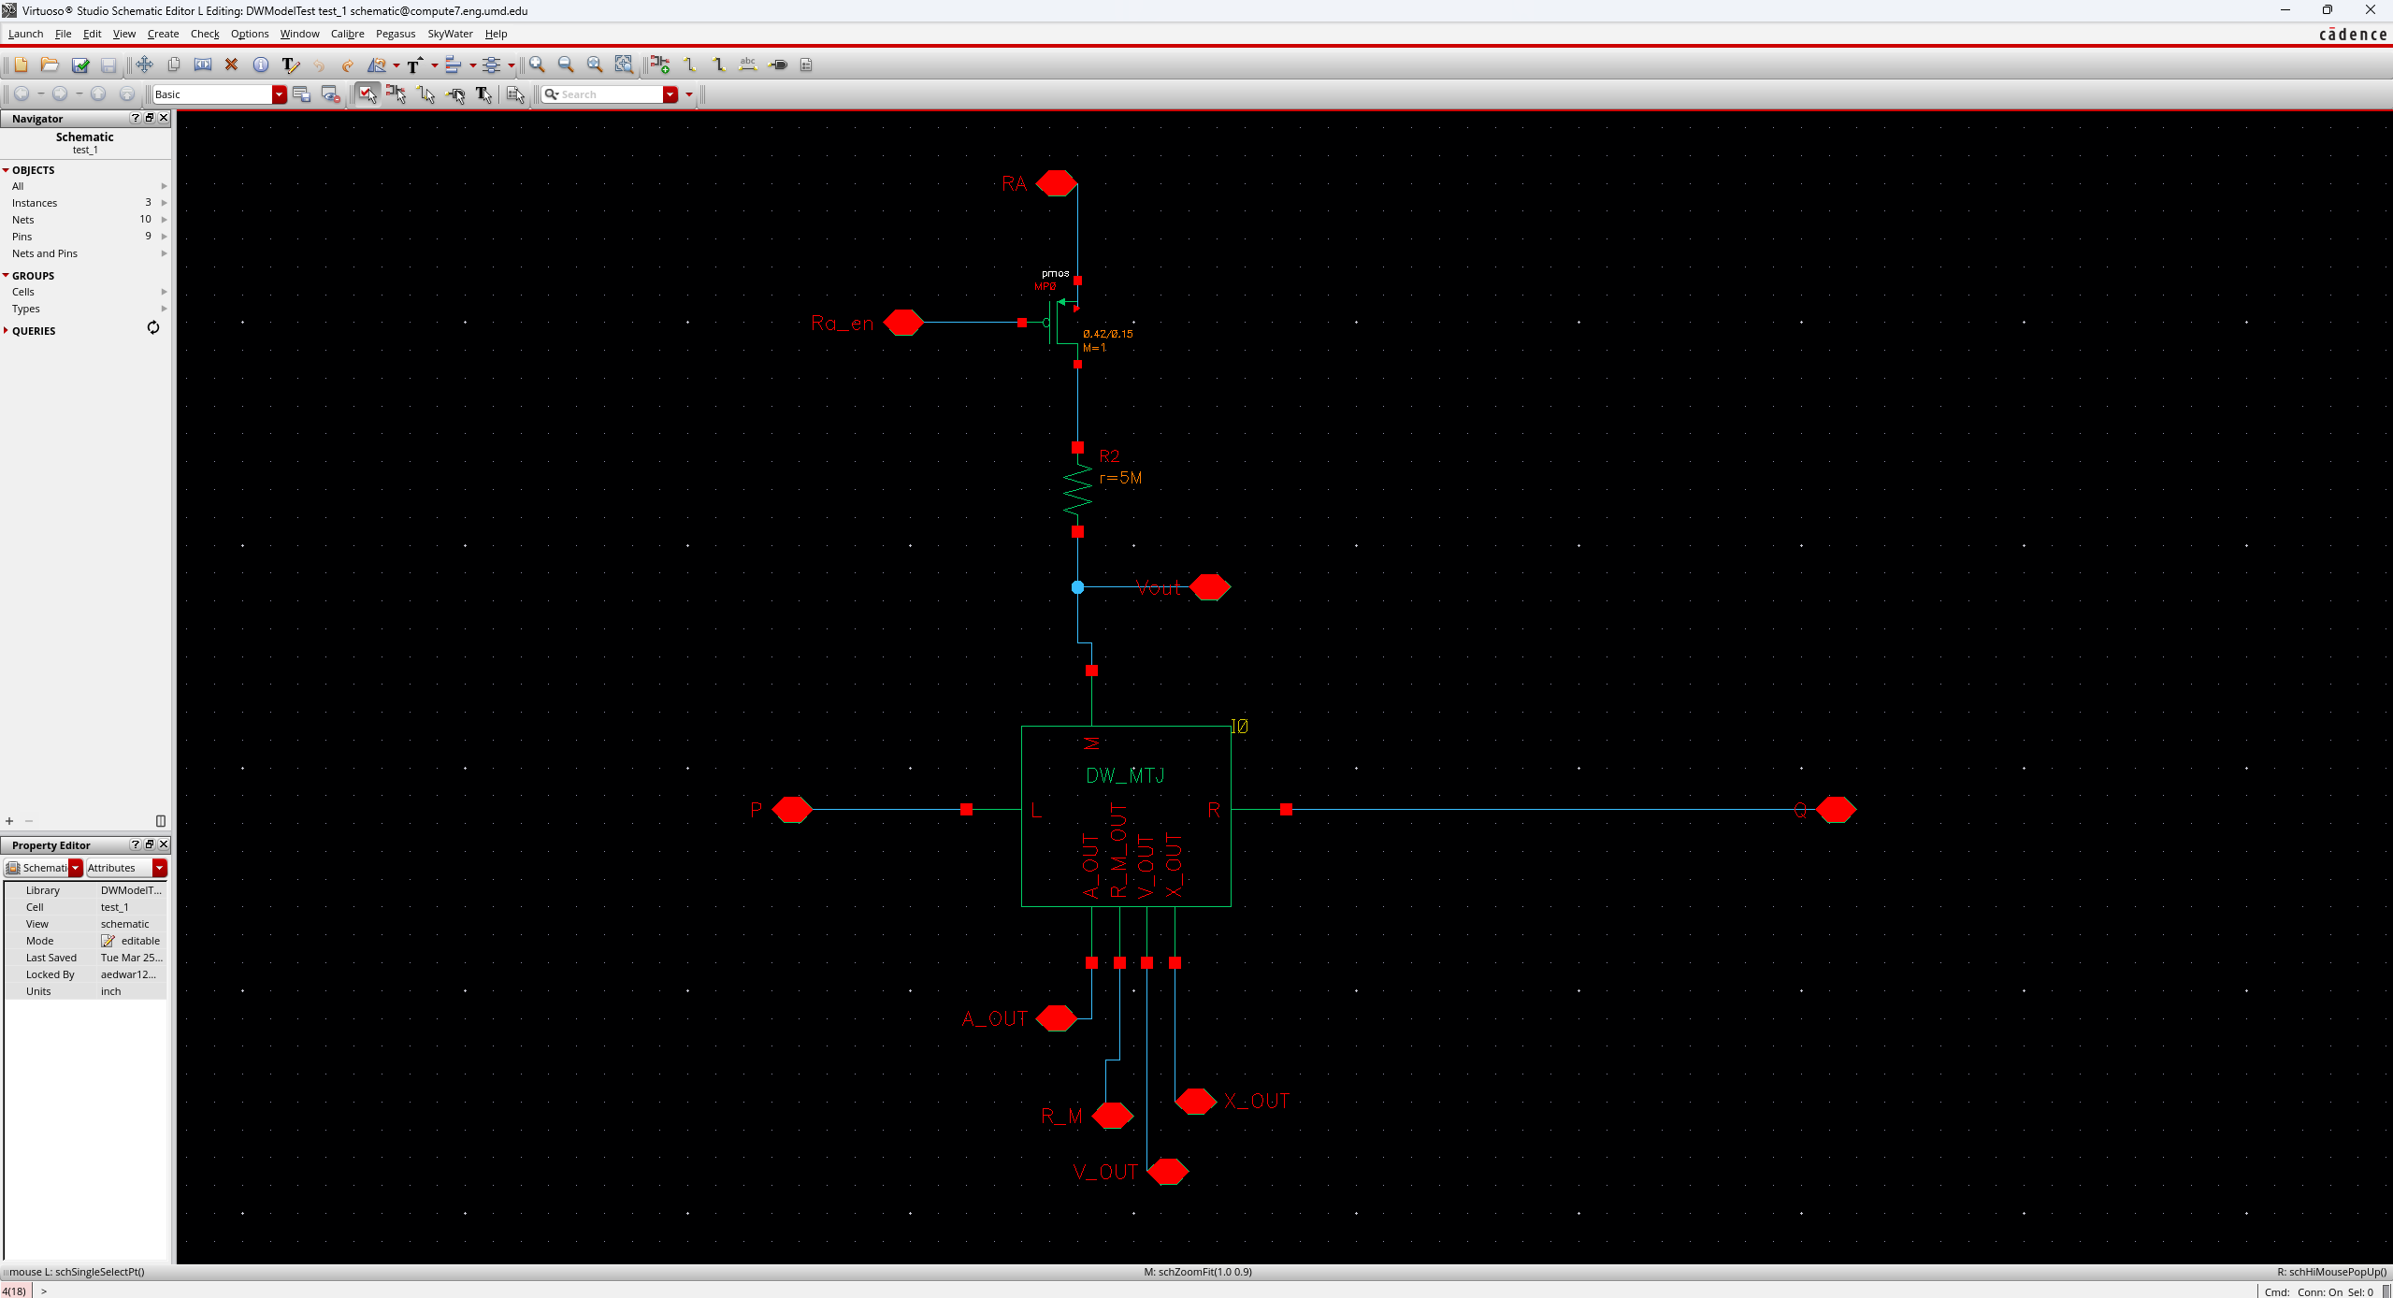

Schematic using sky130 process. All dwmtj model parameters are default. If you manage to get the included tarball loaded in virtuoso, it’s worth diffing the DW_MTJ/veriloga with that on the github. The github will be the most up to date.

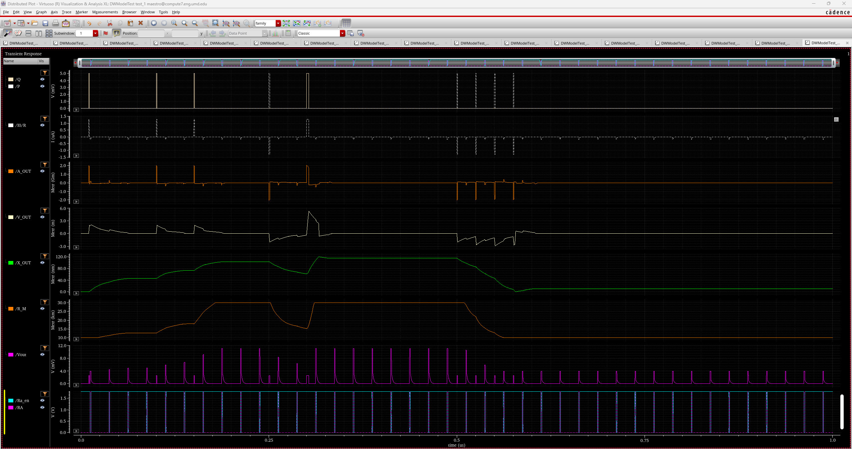

Waveform. Stimuli file included as _graphical_stimuli.scs, Vin = 5mV